Attachment 2
Map of Big Creek Lake
and
Land Owned by MAWSS

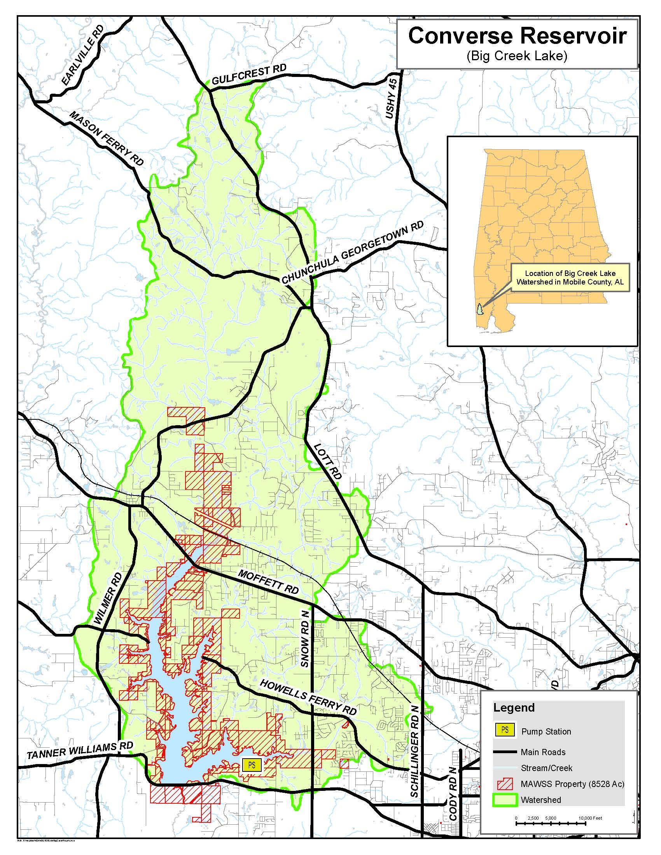

Attachment 3
Task Order Form

Attachment 4
Consultant Fee Schedule

MAWSS Forest Management Services
Schedule of Fees

1. Total Cost to Prepare Forestry Annual Report (FAR): $_____________

2. Total Cost to Add Timber Cruise to FAR: $_____________

3. Timber Cruise Cost per Acre: $_____________

4. Percent of Gross Proceeds for harvest cuts, pole thinnings and pine saw timber sales: _____%

5. Percent of Gross Proceeds for hardwood and pulpwood thinnings sales: _____%
6. Percent of Subcontractor Expense for forestry service subcontractors: _____%
7. List names, positions and hourly rates below:

Base % for Billable
Name Job Title Hourly Rate OH&P Hourly Rate

____________________ ________________________ $________ ____% $________

____________________ ________________________ $________ ____% $________

____________________ ________________________ $________ ____% $________

____________________ ________________________ $________ ____% $________

Consultant Signature: _____________________________ Date: _______________

Attachment 5
MAWSS DBE Policy 16-01

Board of Water and Sewer Commissioners Policy No.: Supplier Diversity 16-01 Approved: December 5, 2016
Amended: October 2017
Amended: February 1, 2021

SUPPLIER DIVERSITY POLICY FOR PUBLIC WORKS ACT CONTRACTS

PURPOSE:

The purpose of this policy is to increase meaningful participation of Diverse Contractors/Suppliers in MAWSS contracts, which are subject to the bidding requirements of the Public Works Act, to establish MAWSS’s goals for Supplier Diversity participation, and to set forth requirements for the MAWSS Supplier Diversity Program.

SCOPE:

This policy will apply to all MAWSS publicly bid contracts for public works and the consultants who manage these contracts. If a contract is to be paid all or in part with non-MAWSS funds, and a funding entity has Supplier Diversity program requirements that exceed or are more stringent than those of this Policy, then the additional Supplier Diversity policy provisions of the funding entity or entities will also apply as contract requirements. Contracts for public works, which do not meet the dollar threshold for public advertisement for bids, will be subject to MAWSS’s Supplier Diversity Policy for Contracts for Goods, Services, and Small Public Works Projects.

In the event that MAWSS must enter into a contract for a public works project on an emergency basis, MAWSS will still seek competitive bids for the work and will declare the nature of the emergency in writing, in accordance with the Public Works Act. MAWSS reserves the right to waive or modify the requirements of this policy if the emergency is adversely affecting or presents and immediate threat to public health, safety, or the environment.

DEFINITIONS:

Contractor - An individual or business entity seeking to contract with MAWSS for a public works project and which will function in the role of general contractor for the project.

Diverse Contractor/Supplier - A for profit small business concern for which socially and economically disadvantaged individuals own at least a 51% interest and also control management and daily business operations, certified as such on one or more of the lists of Diverse/Contractors Suppliers referenced in this Policy.

MAWSS - Mobile Area Water and Sewer System.

Public Works Project - This will be as defined in §39-2-1, Code of Alabama, (1975), as amended.

Subcontractor - For purposes of this Policy, a subcontractor means an individual or business entity which subcontracts with the general contractor to perform work or services for a public works project.

Supplier - For purposes of this Policy, an individual or business entity who enters into a contract with a general contractor to provide materials, equipment, or other products or items for a project.

Supplies - For purposes of this Policy, this term may include materials, equipment, supplies, or other products or items for a project.

Commercial Useful Function –As used in this Policy, refers to the role of a for- profit business which is itself responsible for execution of the contract or a distinct element of the work; refers to a company or individual who actually performs, manages, or supervises the work involved, or who itself furnishes supplies, goods, or services. It is the intent of this Policy that contracts shall be awarded only to entities, which perform commercially useful functions, as opposed to entities that only serve a “pass-through” function.

POLICY:

It is MAWSS policy that Diverse Contractors/Suppliers be given ample and fair opportunities to do business with MAWSS, either directly or indirectly, by ensuring that contractors who enter into publicly bid public works contracts with MAWSS make earnest and diligent efforts to include Diverse Contractors/Suppliers as subcontractors and suppliers. Contractors who wish to bid on a MAWSS public works project shall take all necessary and reasonable steps in accordance with this Policy to ensure that Diverse Contractors/Suppliers have the maximum allowable opportunity to compete for subcontracts and supplier contracts for the project.

This Policy shall be race and gender-neutral. Contractors shall not discriminate in awarding subcontracts and supplier contracts on the basis of race, color, national origin, ethnicity, or sex, during the bid process as well as during performance of a MAWSS public works contract.

It is MAWSS’s goal that in contracts for public works, contractors shall make a demonstrated good faith effort to award fifteen percent (15%) of the contract amount to certified Diverse Contractors/Suppliers as subcontractors and/or suppliers performing commercially useful functions which are consistent with contract requirements. This percentage shall be considered a target which is subject to modifications and may be waived or adjusted by MAWSS if the contractor, after demonstrating a good faith effort, is unable to comply with the 15% goal. However, the requirement that a contractor demonstrate a good faith effort shall not be considered informality subject to waiver, except in cases of emergency as noted above.

IMPLEMENTATION - THE MAWSS SUPPLIER DIVERSITY PROGRAM:

- Lists of Certified Diverse Contractors/Suppliers:

All contractors submitting bids for MAWSS public works contracts are required to utilize MAWSS’s most recent list of certified Diverse Contractors/Suppliers in their efforts to meet their good faith

Supplier Diversity requirements. Bidders may also use the other lists specified below. If a bidder plans to use a Diverse Contractor/Supplier from one of the other lists, the bidder must notify MAWSS’s Supplier Diversity Office so that the Diverse Contractors/Supplier’s certification can be verified.

MAWSS’s list of certified Diverse Contractors/Suppliers includes a description of the areas for which each Diverse Contractor/Supplier can provide services or supplies. Contractors are required to use Diverse Contractors/Suppliers only in the areas for which the Diverse Contractors/Suppliers are certified.

Diverse Contractors/Suppliers may be selected from the following lists:
  - MAWSS List of Certified Diverse Contractors/Suppliers - www.mawss.com (Reciprocity from the following)

  - Alabama Department of Transportation Certified List - www.dot.state.al.us

  - SRMSDC Certified List [Southern Region Minority Supplier Development Council] www.srmsdc.org

  - ADECA Certified List [Alabama Department of Economic and Community Affairs] www.adeca.alabama.gov

  - WBENC Women’s Business Enterprise National Council - www.wbenc.org

  - VOSBA Veteran’s Office of Small Business Administration – www.VOSBA.org
A contractor may also contact MAWSS’s Supplier Diversity Office if the contractor knows of a Diverse Contractor/Supplier who would like to be added to the MAWSS certified list in order to qualify as a subcontractor or a supplier. The MAWSS Supplier Diversity Office will work with the contractor and the Diverse Contractor/Supplier to determine if the Diverse Contractor/Supplier meets certification requirements.

The current listings of Diverse Contractors/Suppliers certified by MAWSS are available on MAWSS’s website: www.mawss.com or by contacting MAWSS’s Supplier Diversity Office at (251) 694-3194.

- Supplier Diversity Requirements:

Contractors who wish to enter into a public works contract with MAWSS must make good faith efforts to comply with MAWSS’s goals for Diverse Contractor/Supplier participation by learning about, contacting, and negotiating with potential Diverse Contractors/Suppliers who are able and available to provide work or supplies for the project.

In addition to obtaining lists of certified Diverse Contractors/Suppliers, Contractors will contact organizations, which provide assistance to Diverse Contractors/Suppliers and obtain contact information for Diverse Contractors/Suppliers available to provide services and materials. A list of such organizations is available from the MAWSS Supplier Diversity Office.

Contractors will then contact certified Diverse Contractors/Suppliers to obtain prices and other information necessary for the contractor to evaluate the possibility of participation by Diverse Contractors/Suppliers.

Contractors bidding on MAWSS public works projects must list all Diverse Contractor/Supplier subcontractors and suppliers on the Subcontracting Plan form submitted in the bid package and sign the form. When

preparing a bid, the bidding contractor must obtain firm prices from all Diverse Contractors/Suppliers. The bid package must include correspondence from each Diverse Contractor/Supplier subcontractor/supplier on the Diverse Contractors/Suppliers letterhead in which the Diverse Contractor/Supplier confirms negotiated terms for the subcontract or supply contract, including compensation and a brief description of the scope of work or the items to be supplied.

If a contractor bidding for a MAWSS contract is unable to meet the 15% goal for Supplier Diversity participation for the project, the contractor must note this on the Subcontracting Plan form, state what percentage of the goal was achieved, if any, and sign the form. The contractor must also submit an Affidavit of Contractor’s Good Faith Efforts to Meet Supplier Diversity Goals with the bid package setting forth the reasons the goal could not be achieved for this project. The Affidavit must include names, addresses, and contact information for each Diverse Contractor/Supplier contacted, a description of information provided to each, and a statement regarding each as to why an agreement for a subcontract or supply contract was not reached. The Affidavit must include description of the good faith efforts made to obtain Supplier Diversity participation, referencing the factors listed below. Documentation supporting the statements in the Affidavit must be attached thereto.

- Demonstrating good faith efforts to meet MAWSS’s Supplier Diversity goals for a public works contract:

When bids are received for a public works contract, MAWSS’s Supplier Diversity Office will review the submittals relative to Supplier Diversity Program requirements to determine if a bidder has demonstrated a good faith effort to reach MAWSS’s Diverse Contractor/Supplier participation goal, the MAWSS Supplier Diversity Office will review and consider bidder’s submitted documentation as to the following factors:

  - Did the bidder obtain the MAWSS List of Certified Diverse Contractor/Supplier entities? What other lists of certified Diverse Contractors/Suppliers did the bidder use, if any?

  - Did the bidder use the services of available community organizations, small and/or disadvantaged business groups, local, state, and federal small or disadvantaged business assistance offices, and other organizations which provide assistance in recruitment and placement of Diverse Contractors/Suppliers, to obtain information and contact information for Diverse Contractors/Suppliers who might be able to perform work or furnish supplies for the project?

  - Did the bidder attend pre-bid meetings scheduled by MAWSS to which Diverse Contractors/Suppliers were also invited, to inform Diverse Contractors/Suppliers of opportunities to provide services or supplies for the project?

  - Did the bidder advertise in general circulation media and trade association publications concerning Diverse Contractor/Supplier opportunities for the project and give potential subcontractors and suppliers reasonable time to respond and negotiate?

  - Did the bidder provide written notice to a reasonable number of Diverse Contractor/Supplier firms and allow them sufficient time to respond and negotiate?

  - Was the information provided by the bidder to potential Diverse Contractor/Supplier subcontractors and suppliers adequate to apprise them of the plans, specifications, and requirements for the project?

  - If the bidder received initial solicitations from interested Diverse Contractors/Suppliers, did the bidder follow up by contacting the Diverse Suppliers again to determine if the Diverse Contractors/Suppliers were interested in subcontracting or furnishing supplies for the project?

  - What efforts did the bidder make to determine whether the project specifications, drawings, and other documents presented opportunities for participation by Diverse Contractors/Suppliers? Did the bidder select certain portions of the work as suitable for performance by Diverse Contractor/Supplier subcontractors, or break down the work into smaller parts in order to allow participation by Diverse Contractors/Suppliers?

  - For any Diverse Contractor/Supplier determined by the bidder to be unqualified or unable to participate, did the bidder offer a reasonable justification for the bidder’s decision not to utilize that Diverse Contractor/Supplier?

  - If the bidder contacted the MAWSS Supplier Diversity Office requesting that potential subcontractors or suppliers be considered for addition to the MAWSS certification list, this should also be documented and will be considered by MAWSS.

The foregoing list is not exclusive. Other efforts to comply may be documented by a bidder for consideration by MAWSS.

Bidders shall have until the close of business on the fourth day after the bid opening to submit complete information in compliance with the Supplier Diversity Program. Additional information, such as clarifying documentation, provided after the close of business on the fourth day after the bid opening shall only be provided and/or accepted upon request of the MAWSS’ Supplier Diversity Office and such information shall be submitted as expeditiously as possible so MAWSS can determine if the bid is in compliance with this policy.

Contractors are hereby notified that bids which do not comply with MAWSS’s Supplier Diversity Policy and Program requirements may be rejected as non-responsive.

- Continuing compliance with the MAWSS Supplier Diversity Program during performance of contract:

MAWSS’s Supplier Diversity Office will monitor continuing compliance with the Supplier Diversity Program requirements as contracts are performed.

If a subcontract or supply contract with a Diverse Contractor/Supplier is terminated prior to its termination date, the contractor must notify MAWSS’s Supplier Diversity Office. This notification must include the reasons for the early termination as well as a description of efforts made by the contractor to engage another certified Diverse Contractors/Suppliers as a replacement subcontractor or supplier.

The contractor must file a written report with MAWSS’s Supplier Diversity Office once a month documenting the contractor’s continuing compliance with the Supplier Diversity Program. This report will list all Diverse Contractor/Supplier subcontractors and suppliers currently performing work or providing supplies for the project.

Information and data requested by the Supplier Diversity Office regarding compliance with the Supplier Diversity Program must be promptly provided by the contractor. Contractors shall make available to MAWSS’s Supplier Diversity Office all records pertaining to use of Diverse Contractor/Supplier subcontractors and suppliers.

MAWSS reserves the right to make site visits to project locations to confirm compliance with Supplier Diversity Program requirements.

A contractor’s failure to comply with this policy and MAWSS’s Supplier Diversity program requirements during performance of a contract may be considered a breach of the contract and may result in its termination.

By entering into a contract with MAWSS, a contractor acknowledges and agrees that failure to comply with MAWSS’s Supplier Diversity Program requirements relative to that contract shall be grounds for its termination by MAWSS.

Failure by a contractor performing a public works project for MAWSS to comply with the Supplier Diversity Program requirements may result in that contractor being determined “not a responsible bidder” in bids for future MAWSS contracts.

Contractors must maintain for three (3) years such records as are necessary to determine compliance with MAWSS’s Supplier Diversity policy.

- MAWSS tracking of Supplier Diversity Program Achievements:

MAWSS’s Supplier Diversity Manager will report to the MAWSS Board semi-annually, in January and in July of each year, on Supplier Diversity utilization and on other efforts by MAWSS’s Supplier Diversity Office to enhance Diverse Contractor/Supplier participation in MAWSS’s public works contracts.
MAWSS may also contract for Disparity Studies as determined by the Board, to provide further information to enhance MAWSS’s Supplier Diversity Program.

Attachment 6
Subcontracting Plan

SUBCONTRACTING PLAN

In order for your Task Order to be considered, Consultant must complete all blanks in this Subcontracting Plan and sign with a handwritten signature where indicated below.

Failure to fill in the blanks on this Subcontracting Plan and/or to include a handwritten signature will prevent approval of Task Order.

It is MAWSS's goal that in all contracts, contractors/consultants shall make a demonstrated good faith effort to award 15% of the Task Order amount to certified Disadvantaged Business Entities [DBE's] / Diverse Suppliers as subcontractors and/or supplier performing commercially useful functions which are consistent with contract requirements.

Copies of MAWSS DBE Policy 16-01 [for public works projects], DBE/Supplier Diversity Policy 17-01 [for contracts for other goods and services], MAWSS's list of certified Disadvantaged Business Enterprises [DBE's] / Diverse Suppliers, and lists of organizations that have information on DBE's / Diverse Suppliers are available from MAWSS's Supplier Diversity Office (251-
694-3194) or from the MAWSS website, www.mawss.com.

PLEASE STATE WHAT PERCENTAGE OF THE WORK FOR THIS CONTRACT YOU PLAN  TO AWARD TO DBE/DIVERSE SUPPLIER SUBCONTRACTORS AND/OR VENDORS: | (Total %)
ESTIMATED TOTAL DOLLAR AMOUNT TO BE AWARDED TO DBE/DIVERSE SUPPLIER: | (Total $)
AMOUNT BID FOR THIS CONTRACT: | (Total $)

If the above percentage is zero or is less than 15%, be sure to include your Affidavit of Contractor's Good Faith Efforts to
Meet Subcontractor / Vendor Diversity Goals and all supporting documentation with your Task Order package.

Please list below all subcontractors and suppliers which you plan to use for this Task Order. Also indicate which of these are DBE's / Diverse Supplier by writing "yes" or "no" where indicated. Also list for each the percentage of the total contract amount to be performed by each and the certification group the DBE / Diverse Supplier certified with. Attach additional sheets if needed. [If you are not using any subcontractors or vendors, you will need to write "zero" below and sign the form.]

DBE/DIVERSE CERTIFICATION GROUP
SUBCONTRACTOR/ SUPPLIER? % OF (MAWSS, ALDOT, ADECA,
VENDOR NAME SERVICE TYPE Yes or No CONTRACT AMT SRMSDC, ADECA, WBENC, VOSBA)

_______________________ _____________________ ________ _________ _____________________

_______________________ _____________________ ________ _________ _____________________

_______________________ _____________________ ________ _________ _____________________

_______________________ _____________________ ________ _________ _____________________

I WILL EXERCISE GOOD FAITH TO COMPLY WITH THIS PLAN AND MAWSS' DBE REQUIREMENTS.

Consultant

By: ___________________________________

For more information regarding the MAWSS Supplier Diversity Program, contact Ms. Felicia Thomas, Supplier Diversity Manager, at Phone 251-694-3194, Cell 251-422-1168 or fthomas@mawss.com.

