Request For Proposal

**PROFESSIONAL FOREST**

**MANAGEMENT SERVICES**

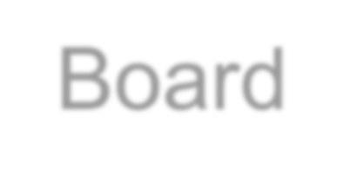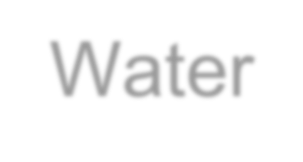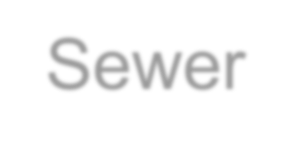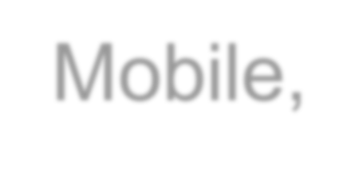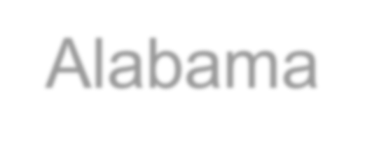

The Board of Water and Sewer Commissioners of the City of Mobile, Alabama

Submission Date: November 7, 2023

**Request For Proposal**

**PROFESSIONAL FOREST MANAGEMENT SERVICES**

The Mobile Area Water and Sewer System (MAWSS) is soliciting proposals from qualified firms to perform forest management tasks in accordance with Alabama State Law. Please respond to this Request for Proposal (RFP).

# Completed, signed and sealed proposals should be delivered no later than 10:00 a.m. local time, Tuesday, November 7, 2023 to:

Markus Moore, Engineer II

Mobile Area Water & Sewer System

4725 Moffett Road

Mobile, AL 36618

Proposals received after this date and time will not be considered. The proposal shall be submitted in one (1) sealed envelope clearly marked as **“Forest Management Services Proposal.”** Inside the sealed envelope, two (2) envelopes shall be included containing the following information:

Envelope #1 - Statement of Qualifications (SOQ).

Envelope #2 – Cost Proposal and terms.

The envelopes must contain one (1) original suitable for reproduction*. If said markings are not clearly visible on envelopes, envelopes will not be opened or considered.*

The Proposer must comply with these RFP requirements. Copies of the RFP, proposal forms, and requirements may be obtained by contacting the office of the MAWSS Project Manager,

Markus Moore, Engineer II

Mobile Area Water & Sewer System

4725 Moffett Road

Mobile, AL 36618

(251) 721-0828

This is a request for a proposal. This document does not constitute an order and/or a contract for services. Mobile Area Water & Sewer System reserves the right to reject any and/or all proposals, to make awards as they may appear advantageous to MAWSS, and to waive all formalities and irregularities in bidding.

**REQUEST FOR PROPOSALS**

**Professional Forest Management Services**

The Board of Water & Sewer Commissioners of the City of Mobile, dba MAWSS (hereinafter referred to as the Board or MAWSS), is accepting Proposals from companies interested in providing professional forest management services to the Board. The company selected by the Board will be offered the opportunity to enter into a Forest Management Services Agreement with the Board for a one-year period plus two additional years if both the Board and the selected company agree to an extension on an annual basis. The initial one-year period is from January 1, 2024 to December 31, 2024. The total three-year period terminates on December 31, 2026.

**Proposal Submittal**

Proposals must be received at the Park Forest office of MAWSS at 4725 Moffett Road, Suite H, Mobile, Alabama, by close of business (10:00 a.m. CST) on November 7, 2023, to be considered. Any response received after that time and date will remain unopened. Responses should be mailed or hand-delivered to Markus Moore, Engineer II. Mr. Moore’s telephone number is 251-721-0828.

All responses shall be submitted in a sealed envelope plainly marked **“****Forest Management Services Proposal.”** The sealed envelope must contain both the Statement of Qualifications (SOQ) and another sealed envelope containing the Cost Proposal and terms. The SOQ and Cost Proposal requirements are described below.  **Provide six copies of the Forest Management Services Proposal.**

**Forest Management Services Agreement**

The Forest Management Services Agreement is attached for your review and consideration. Please review the Agreement for details regarding contractual provisions and description of the work to be performed.

**Proposal Content Requirements and Points Allocation**

**I. Statement of Qualifications/Technical Proposal**

SOQs must be submitted in the format identified below. Non-compliance with the format requirements may result in the SOQ being rejected.

Qualified companies interested in submitting a SOQ must submit the information identified below in a document with a binding.

Each subsection of the SOQ, which is identified by a lettered title below, must be preceded with a divider page containing a tab labeled with the appropriate letter of the subsection as shown below.

**A. Transmittal Letter (1 Page)**

The first page of the document shall be a letter from the company transmitting the Statement of Qualifications (SOQ) to the Board. The letter must certify that the information provided in the SOQ is accurate and is signed by an appropriate officer of the company.

Include in the letter the name and contact information of the person to whom questions about the SOQ should be addressed.

**B. General Information about the Company (1 Page)(Max 5 Points)**

Provide general information about the company’s size, office location, expertise, years in business, and any other general credentials that characterize the company.

**C. Forest Management Services Offered to MAWSS (Do Not Exceed 15 Pages)(Max 40 Points)**

Provide a narrative that describes the company’s experience and credentials relative to the work described in the Forest Management Services Agreement. List relevant project descriptions completed, clients and any other pertinent information that accurately describes the company’s history and current capabilities specifically related to the work described in the attached Agreement.

Provide examples of reports or work products that will be similar to those proposed for services provided to MAWSS.

Identify the client services manager who will be the primary contact for the Board if the company is selected. Show the client services manager office location and contact information. Attach a resume of the client services manager.

Note that the work described in the Forest Management Services Agreement must be managed by a Forester currently licensed by the Alabama State Board of Registered Foresters. Identify the Forester name, Alabama license number, date license issued, date license will expire, and role this person will have in performing the services identified in the Agreement.

Identify any other personnel who will be used in the performance of the Agreement by providing a summary of their roles and placing their resumes in the SOQ.

**D. In-house and Out-of-House Capabilities (Do Not Exceed 2 Pages)(Max 5 Points)**

Describe the work that will be performed by the company’s in-house staff.

Describe the work that will be performed by subcontractors. Provide names and addresses of subcontractors and their experience related to the work described in the Agreement, if known.

**E. Prior Experience with the Board (1 Page)(Max 10 Points)**

Identify whether or not the Company has had prior experience working for the Board in a similar capacity either directly or as a subcontractor to another company. Describe the work performed for the Board.

**F. Proximity to MAWSS (1 Page)**

Identify the address of the nearest company office to MAWSS at 4725 Moffett Road. State when the office was opened. Identify the distance from 4725 Moffett Road to the nearest company office. Identify the resources and capabilities that exist within the nearest office.

**G. Other (Do Not Exceed 3 Pages)(Max 5 Points)**

Identify any characteristic of the company not listed elsewhere in the SOQ that would provide value to MAWSS if the company is selected.

**H. Small and Underutilized Businesses (SUBs)(Do Not Exceed 3 Pages)(Max 10 Points)**

MAWSS encourages all companies to use qualified SUBs in the performance of MAWSS projects.

MAWSS also expects company to make a good faith effort in meeting the Diversity Supplier Program by MAWSS. Please identify your approach to using diverse suppliers in accordance with MAWSS DBE Policy 16-01 as shown in the Forest Management Services Agreement, Attachment 4.

**I. References (Do Not Exceed 2 Pages)(Max 15 Points)**

Identify three references with contact information and a brief summary of the work provided to them. Include the dates on which services were provided to each reference.

**J. Company/Proposer Guarantees and Warrantees**

Sign the Proposer Guarantee in Appendix A and the Proposer Warranty in Appendix B and include in the SOQ. SOQs that do not have these signed documents will be rejected.

**II. Cost Proposal (Place in Sealed Envelope to Separate It from SOQ)**

Complete the MAWSS Forest Management Services Schedule of Fees in Appendix C and place it in an envelope. Mark on the envelope, “Forest Management Services Schedule of Fees,” and place it in the larger envelope that contains the qualifications proposal(SOQ).

The various fees identified in the “MAWSS Forest Management Services Schedule of Fees” are described in the Forest Management Services Agreement, Article Eighteen, Compensation for Services.

**Notices**

The Board reserves the right to waive any informality in the selection process when such waiver is in the best interest of the Board and to reject any and all Statements of Qualifications.

The cost of developing a response to this RFP is borne by the company making the submittal. The Board shall have no obligation to reimburse any expense whatsoever associated with developing and furnishing responses to this RFP.

Companies responding to this RFP are not guaranteed to receive award of the Forest Management Services Agreement.

The company who contracts with the Board will be used on an as-needed basis. There is no guarantee that work or any set amount of work will be provided in any particular year.

The Board may, at any time in the future, release additional RFPs and/or pursue agreements with companies other than the one selected as a result of this RFQ.

All questions regarding the RFP must be submitted to Markus Moore, Engineer II, in writing at [Mamoore@mawss.com](mailto:Mamoore@mawss.com) prior to 4:00 p.m. CST, October 27, 2023. Questions after October 27, 2023, will not be answered.

**Schedule**

October 27, 2023 Questions or comments due to MAWSS

November 7, 2023 Proposals due to MAWSS

December 4, 2023 Company Selection on Board Agenda for Action.

December 20, 2023 MAWSS receives executed Agreement and Cert. of Insurance by this date.

**EVALUATION PROCEDURES**

Proposals submitted will be evaluated by a review team consisting of MAWSS staff and then by the Board or a Board Committee.

**I. Selection Process**

Each member of the review team will independently assign points to the subsections in Section I. above. The full team will then convene and sum the points for each subsection above and derive cumulative SOQ scores for each company. Then the companies will be ranked according to the cumulative SOQ scores. If any company has unacceptably low SOQ scores at this point in the review, it will be eliminated from the list.

After the initial composite scores for the remaining companies have been established and the companies ranked, accordingly, the cost proposals for the remaining companies will be opened and considered in combination with each SOQ score. The cost proposal has no assigned weight. The review team will rank companies according the best overall value when considering both price and SOQ ranking.

The review team will make a recommendation to the Board or a Board Committee. The Board or Board Committee may request oral presentations from the top two or three companies competing for the Forest Management Services Agreement.

The review team and Board or Board Committee will discuss all information provided and make a final decision.

The Board’s decision in selecting a company will be final.

**II. Date of Final Decision**

The Board is expected to act on the selection of a Forest Management Services Company at the December 4, 2023 Board Meeting.

The Board’s decision in selecting a company will be final.

**III. Agreement Execution**

Following notification of the company selected, it is expected that a contract will be executed between both parties by December 20, 2023.

**IV. Right to Reject Proposals**

Submission of a proposal indicates acceptance by the firm of the conditions contained in this request for proposals, unless clearly and specifically noted in the proposal submitted and confirmed in the contract between the Board and the firm selected.

**APPENDIX A**

**PROPOSER GUARANTEES**

**The proposer certifies it can and will provide and make available, at a minimum, all services set forth in the Forest Management Services Agreement.**

Signature of Official: _______________________________________________

Name (typed): ____________________________________________________

Title: ____________________________________________________________

Firm: ____________________________________________________________

Date: ____________________________________________________________

**APPENDIX B**

**PROPOSER WARRANTIES**

A. Proposer warrants that it is willing and able to obtain an insurance policy providing the amount and type of coverage required in the Forest Management Services Agreement.

B. Proposer warrants that it will not delegate or subcontract its responsibilities as stipulated in the Forest Management Services Agreement without the express prior written permission of the Board of Water and Sewer Commissioners of the City of Mobile.

C. Proposer warrants that all information provided by it in connection with this proposal is true and accurate.

Signature of Official: ________________________________________

Name (typed): _____________________________________________

Title: ____________________________________________________

Firm: ____________________________________________________

**APPENDIX C**